Presented To:
City of Henderson HOME-ARP Allocation Plan

Presented To:
U.S. Department of Housing and Urban Development (HUD)

Prepared By:
City of Henderson Community Development & Services
240 S. Water St, MSC 000
Henderson, NV 89015

Substantial Amendment to the 2021 Annual Action plan
Table of Contents
Executive Summary 3
Consultation 4
Consultation Summary 5
Public Participation 11
Public Participation Process 12
Needs Assessment and Gaps Analysis 14
Size and demographic composition of qualifying populations within the PJ’s boundaries: 16
Homeless as defined in 24 CFR 91.5 16
At Risk of Homelessness as defined in 24 CFR 91.5 17
Fleeing, or Attempting to Flee, Domestic Violence, Dating Violence, Sexual Assault, Stalking, or Human Trafficking, as defined by HUD in the Notice 18
Other populations requiring services or housing assistance to prevent homelessness and other populations at greatest risk of housing instability, as defined by HUD in the Notice 18
Veterans and families that include a veteran family member that meet the criteria in one of qualifying populations 19
Identify Priority Needs for Qualifying Populations: 21
Homeless 22
At risk of homelessness 22
Fleeing, or attempting to flee domestic violence, dating violence, sexual assault, stalking, or human trafficking 22
HOME-ARP Activities 24
HOME-ARP Production Housing Goals 25
Preferences 27
Referral Methods 27
HOME-ARP Refinancing Guidelines 29
Attachments 31
Attachment A: HOME ARP (American Rescue Plan) Funding - Provider Survey 32
Attachment B: Infographic & Link to survey (English) 36
Attachment C: Infographic & Link to survey (Spanish) 37
Attachment D: Community Feedback Survey (English) 38
Attachment E: Community Feedback Survey (Spanish) 40
Attachment F: Henderson HOME-ARP Presentation 42
Attachment G: Southern Nevada Continuum of Care Data 46

Executive Summary
As a recipient of HOME Investment Partnerships Program (HOME) funds from the U.S. Department of Housing and Urban Development (HUD), the City of Henderson is eligible to receive $2.5 million in HOME American Rescue Plan (ARP) funds to perform activities that primarily benefit individuals and families who are (1) homeless, (2) at risk of homelessness (3) fleeing, or attempting to flee domestic violence, dating violence, sexual assault, stalking, or human trafficking; (4) part of other populations where providing supportive services or assistance would prevent a family’s homelessness or would serve those with the greatest risk of housing instability; or (5) veterans and families that include a veteran family member that meet the criteria in one of (1)-(4) above.

The City of Henderson will identify the most impactful uses of the HOME ARP funds, understanding that these funds can be used for the four eligible activities:
- Production or Preservation of Affordable Housing
- Tenant-Based Rental Assistance (TBRA)
- Supportive Services, Homeless Prevention Services, and Housing Counseling
- Purchase and Development of Non-Congregate Shelter

The City of Henderson Approach to Addressing Homelessness
The City of Henderson responds to homelessness through regional collaboration, research, and advocacy. The City of Henderson’s Community Development and Services Department has developed a robust approach to proactively respond to the growing population and changing housing needs in Henderson. This approach required collaboration with other City departments, community stakeholders, business owners, housing developers, financial institutions, and other experts to create the Henderson Housing and Community Development Strategy (HHCDS). One of the key elements in the HHCDS is to prioritize homelessness prevention by dedicating efforts to prevent people from becoming homeless. In addition, the plan addresses the fact that enacting policies and activities to prevent homelessness are as important as are the services that help homeless individuals obtain housing. The HHCDS also included the need to identify grants to increase resources for emergency assistance to serve people already experiencing homelessness and the need to deploy street outreach team because Henderson lacked these resources. The city saw a unique opportunity during the COVID-19 pandemic to apply for grant funding from the State of Nevada Housing Division to address this deficiency. The city applied for and was awarded $1.1 million in Emergency Solutions Grant funds from the CARES Act (ESG-CV) to implement a street outreach team that could engage with people experiencing homelessness, offer emergency shelter, and offer rapid rehousing. Through a partnership with local nonprofit, HELP of Southern Nevada, the Henderson Homeless Response Team (HHRT) launched in October 2021. The HHRT is a street outreach team that provides outreach and engagement and can connect people to services and resources, including food, shelter/housing, healthcare, mental health, and substance abuse treatment.
The City of Henderson also addresses homelessness through its participation with the regional Continuum of Care. The city and other Southern Nevada municipalities are members of the Southern Nevada Homelessness Continuum of Care (SNHCoC), a regional coalition focused on ending homelessness in Southern Nevada communities. The organization includes a broad range of community stakeholders including representatives from governments, businesses, advocates, public housing agencies, school districts, social service providers, mental health agencies, hospitals, universities, affordable housing developers, law enforcement, and other organizations that serve homeless and formerly homeless persons. The SNHCoC’s regional plan to end homelessness is titled Help Hope Home. The Help Hope Home plan was designed through a collaborative process engaging local governments; community providers; faith-based organizations; local businesses and committed individuals who recognized a need to address the issues of homelessness.
The City of Henderson borders Las Vegas on the southern rim of the Las Vegas Valley in Incorporated Clark County, Nevada. Incorporated Clark County consists of Henderson, Las Vegas, and North Las Vegas. These municipal boundaries do not limit the movement and development of encampments throughout the county. The HELP of Southern Nevada’s 2022 Regional Outreach Coordinator Yearly Report states that the deciding factor of why unsheltered homeless population choose a location is that the location is near friends/family, that the location is safe, that it is in close proximity to services and that they are familiar with the area. Because of this, the Henderson HOME-ARP Plan will contain references and data from Clark County.

Consultation
In accordance with Section V.A of the Notice (page 13), before developing its HOME-ARP allocation plan, at a minimum, a PJ must consult with:
- CoC(s) serving the jurisdiction’s geographic area,
- homeless service providers,
- domestic violence and human trafficking service providers
- veterans’ groups,
- public housing agencies (PHAs),
- public agencies that address the needs of the qualifying populations, and
- public or private organizations that address fair housing, civil rights, and the needs of persons with disabilities.

To ensure broad input into the HOME-ARP Allocation Plan from stakeholders and the public, the City of Henderson’s Community Development and Services Department developed a comprehensive approach to maximize the quantity and quality of the consultations.

Describe the consultation process including methods used and dates of consultation:
The City of Henderson’s consultation process included reviewing system-level data, conducting virtual consultations with community partners, reviewing, and utilizing existing Action Plans, Consolidated Plans, consultations, and published data. The first step of the process was to identify the agencies that should be included as a part of the consultations as required per the HOME-ARP planning guidance. Once these were identified, additional impactful organizations were added to the consultation schedule. An initial email was sent to the agencies with the details of the HOME ARP Program, including the amount of funding that the City of Henderson received and the eligible activities. Follow-up emails were sent to all agencies with the choice of either 1) to attend one of three pre-scheduled virtual focus groups, 2) to schedule a small group virtual meeting or 3) to schedule a 1:1 virtual meeting. In addition, an online survey (See Attachment A) was prepared to send to organizations in case they were not able to participate in any of the virtual meetings.

Consultation Summary

Below is a table of the consultations and a summary of the organizations feedback:
Agency/Org Consulted | Type of Agency/Org | Method of Consultation | Feedback
Catholic Charities of Southern NV | Homelessness | Virtual Meeting | QP: At Risk, Other (Support Services), Human Trafficking  Impactful Uses of Funds:  - Permanent Supportive Housing  - Supportive Services  - Rapid Rehousing/Tenant Based Rental Assistance  - Housing Eviction Legal Assistance
Clark County Department of Family Services | Child Welfare Agency | Virtual Meeting | QP: At Risk, Other (Support Services), Human Trafficking  Impactful Uses of Funds:  - Permanent Supportive Housing  - Supportive Services  - Tenant Based Rental Assistance & Utility Assistance  - Non-Profit Operating costs to carry out services
Clark County Department of Social Services | Social Services Agency | Group Meeting | QP: All  Impactful Uses of Funds:  - Permanent Supportive Housing  - Landlord Partnership Program to engage and create more affordable units  - Landlord incentives program  - Outreach and case management for at risk of becoming homeless population
East Valley Family Services | Non-profit Family Service provider | Group Meeting | QP: Homeless, At Risk  Impactful Uses of Funds:  - Permanent Supportive Housing and/or Non-Congregate Shelter to address 3 gaps:  - Seniors with custody of grandchildren.  - Housing for teenage boys not allowed in women’s shelters  - Housing for people with convicted felonies, evictions and credit score issues preventing qualification of housing
HELP of Southern NV | Homelessness | Virtual Meeting | QP: Homeless, Domestic Violence, Other  Impactful Uses of Funds:  - Preservation of Permanent Supportive Housing.  - Support Services  - Rapid Rehousing  - Non-Congregate Housing
HopeLink of Southern NV | Homelessness | Virtual Meeting | QP: Homeless, At Risk  Impactful Uses of Funds:  - Permanent Supportive Housing  - Non-Congregate Shelter  - Capacity Building for Organization  - Operating costs to carry out services
Living Grace Homes | Homeless/Domestic Violence Youth 14-24 | Virtual Meeting | QP: Homeless, Domestic Violence, Other  Impactful Uses of Funds:  - Permanent Supportive Housing Youth and Young adults  - Supportive Services  - Transitional Housing Development Targeted for Youth and Young adults
Nevada Equal Rights Commission (NERC) | Civil Rights | Virtual Meeting | QP: Other  Impactful Uses of Funds:  - Permanent Supportive Housing  - Supportive Services and Fair Housing Training  - Tenant Based Rental Assistance  - Non-Congregate Shelter
Nevada Hand | Nonprofit Developer, Builder, and Manager of Affordable Rental Homes for Seniors and Working Families. | Group Meeting | QP: Other  Impactful Uses of Funds:  - Permanent Supportive Housing  - Transitional Housing  - Housing and Services for unmet youth population who are at risk of becoming homeless, aging out of foster care and sex trafficking victims.
Nevada Institute for Children's Research & Policy (NICRP) | Nonprofit Research and Advocacy Organization | Virtual Meeting | QP: Other  Impactful Uses of Funds:  - Permanent Supportive Housing  - Non-Congregate Shelter with Supportive Services
Nevada Partnership for Homeless Youth | Homelessness | Clark County Consultation | QP: Other  Impactful Uses of Funds:  - Permanent Supportive Housing  - Non-Congregate Shelter  - Support Services
NV Division of Child and Family Services | Family and Child Welfare Service Provider | Virtual Meeting | QP: Other  Impactful Uses of Funds:  - Permanent Supportive Housing to support Youth  - Non-Congregate Shelter (w/student stipends)  - Supportive Services
Ovation | General Contractor and Real Estate Development Company | Clark County Consultation | QP: Other  Impactful Uses of Funds:  - Permanent Supportive Housing  - Tenant Base Rental Assistance  - Supportive Services
Safe House | Domestic Violence | Virtual Meeting | QP: Homeless, Domestic Violence, Human Trafficking  Impactful Uses of Funds:  - Rental Security Deposits to cover damages and provide incentive to Landlords  - Capacity building for client development plans  - Support Services for DV
Safe Nest | Domestic Violence/  Human Trafficking | Virtual Meeting | QP: Domestic Violence  Impactful Uses of Funds:  - Development of Permanent Supportive Housing  - Non-Congregate Shelter  - Support Services
Signs of Hope | Domestic Violence/  Human Trafficking | Virtual Meeting | QP: At Risk, Domestic Violence  Impactful Uses of Funds:  - Supportive Services for people experiencing DV  - Workforce Development for people experiencing DV
Silver State Fair Housing Council | Fair Housing | Virtual Meeting | QP: ALL  Impactful Uses of Funds:  - Permanent Supportive Housing  - Supportive Services to limit barriers to housing access/eligibility  - Non-Congregate Shelter  - Fair Housing Outreach Education services specifically for developers, property managers, community organizations.  - Tenant Based Rental Assistance
Southern Nevada Regional Housing Authority (SNVRHA) | Public Housing Agency | Clark County Consultation | QP: At Risk  Impactful Uses of Funds:  - Permanent Supportive Housing
Southern Nevada Homelessness Continuum of Care (SNHCoC) | Homelessness | Virtual Meeting | QP: ALL  Impactful Uses of Funds:  - Permanent Supportive Housing  - Supportive Services  - Non-Profit Capacity building
St Jude's Ranch for Children | Not for profit organization that provides a safe, nurturing home with therapeutic residential treatment services to abused and neglected children in Nevada | Virtual Meeting | QP: At Risk, Other (Support Services)  Impactful Uses of Funds:  - Permanent Supportive Housing to support Youth  - Development of Transitional Housing to support Youth  - Supportive Services to support Youth  - Capacity Building
US Vets | Veterans | Virtual Meeting | QP: Veterans  Impactful Uses of Funds:  - Transitional Housing  - Supportive Services to mitigate evictions and long-term case management for families impermanent housing
City of Henderson Community Development Services Department | Neighborhood Services | Group | QP: All  Impactful Uses of Funds:  - Permanent Supportive Housing  - Supportive Services  - Capacity Building for Non-Profits  - Operating Costs for Non-Profits
City of Henderson Community Development Services Department | Office of Public Response | Group | QP: All  Impactful Uses of Funds:  - Permanent Supportive Housing  - Supportive Services  - Capacity Building for Non-Profits to expand Homeless Outreach Team  - Operating Costs for Non-Profits to expand Homeless Outreach Team

Summarize feedback received and results of upfront consultation with these entities:
The consultations were conducted from 10/31/22, through 12/08/22. Provider surveys were sent to non-responsive entities. All the required organization types provided consultation input. The following is a summary of some common feedback.

The single most critical issue is the lack of affordable housing. This issue impacts Henderson families in a multitude of ways. It is difficult for people to earn the salaries needed to obtain safe housing, much of the subsidized housing is in undesirable areas, and lack of housing can lead to the removal of children from the household.
For those experiencing homelessness, there is a lack of emergency shelter beds county-wide, permanent supportive housing, and a network of support organizations in Henderson. There is one local non-profit that provides most of the homeless services and another that provides the homeless outreach services. The need to build capacity for current and additional service providers is essential to building a network of services. It is important that wrap around services are available to treat the “whole person” and successfully assist persons experiencing homelessness to stabilize and follow-through to access housing. Homelessness is the result of other personal, financial, or social issues. A critical need for this population is transitional housing to bridge the gap to permanent housing. Once an individual or family does successfully obtain permanent affordable housing, there should be continued support to rebuild the capacity for independent living. There is a lack of permanent supportive housing production, which delays the ability to stabilize people experiencing homelessness.

For those at risk of homelessness, organizations need to be able to intervene before the individual or family is evicted. A frequent comment was that service providers need increased ability and support to provide support services and would benefit from landlord incentives to reimburse a for incidental damage in a unit to avoid eviction. There are some funding sources flexible enough to do this, but for other programs, homelessness is a requirement for eligibility. Access to affordable housing with support and advocacy is needed to ensure independence for those at risk of homelessness. In addition, the vulnerable population of youth and seniors who require custody of grandchildren were highlighted.

For those fleeing, or attempting to flee domestic violence, dating violence, sexual assault, stalking, or human trafficking, safe, appropriate housing and supportive services are needed. It is critical that individuals and families in this group are in housing environments in which they are comfortable and feel safe around the other residents. For those fleeing domestic violence, services should focus on healing and rebuilding confidence. For those fleeing trafficking, services should focus on healing, developing work skills or pursuing additional education. There is a lack of permanent supportive housing production, which delays the ability to stabilize this vulnerable population.

For veterans and families that include a veteran family member that meet the criteria of one of the qualifying populations, the main needs are employment services, mental health services and rapid rehousing. There is a robust Veteran’s Administration organization in Henderson and throughout Clark County. In addition, there are local organizations that supplement the services provided by the Veteran’s Administration.
Regarding the category of “other Populations,” the City of Henderson identified homeless youth and youth at risk of homelessness. The need for housing and support services was highlighted. This vulnerable population may include youth aging out of foster care, victims of sex trafficking which leads to a higher risk of remaining and relapsing into homelessness. There is a need for assistance to build capacity for services that will provide longer term case management for this vulnerable population. Transitional housing to stabilize and bridge the gap to permanent supportive housing is essential. Youth aging out of foster care, youth victims of sex trafficking, youth with children and need additional housing and support services to remain housed.

Public Participation

In accordance with Section V.B of the Notice (page 13), PJs must provide for and encourage citizen participation in the development of the HOME-ARP allocation plan. Before submission of the plan, PJs must provide residents with reasonable notice and an opportunity to comment on the proposed HOME-ARP allocation plan of no less than 15 calendar days. The PJ must follow its adopted requirements for “reasonable notice and an opportunity to comment” for plan amendments in its current citizen participation plan. In addition, PJs must hold at least one public hearing during the development of the HOME-ARP allocation plan and prior to submission.

PJs are required to make the following information available to the public:
- The amount of HOME-ARP the PJ will receive, and
- The range of activities the PJ may undertake.

Throughout the HOME-ARP allocation plan public participation process, the PJ must follow its applicable fair housing and civil rights requirements and procedures for effective communication, accessibility, and reasonable accommodation for persons with disabilities and providing meaningful access to participation by limited English proficient (LEP) residents that are in its current citizen participation plan as required by 24 CFR 91.105 and 91.115.

Public Participation Process

- An infographic (See Attachment B & C) was developed. The Infographic included the amount of HOME-ARP funding that the City of Henderson received and the eligible activities for which these funds could be used. The Infographic also included a link and QR code to a community feedback survey (See Attachment D & E). This infographic was placed on the City of Henderson website in English and Spanish on January 18, 2023.

- A short PowerPoint presentation (See Attachment F) was developed for use at meetings or to be emailed to interested parties.

- Date(s) of public notice: 02/15/23

- Public comment period: Start date – 02/15/23
End date – 03/02/23

- Date(s) of public hearing: 03/07/23

Describe the public participation process:
The Public Notice appeared in the Las Vegas Review Journal and El Tiempo from 02/15/2023 to 03/02/2023. The public notice explained the amount of funding the City of Henderson received and the eligible funding categories for the HOME-ARP Allocation. The Public Notice also explained that the Allocation Plan can be found on the City of Henderson’s website, and any public comment could be submitted in via email at daniel.steklasa@cityofhenderson.com , or community survey on the City of Henderson website. In addition, an email blast will be sent to a group of citizens that have opted-in to receive information about upcoming projects/items for the Community Development department. The Public Notice also provided the date, time, and location for the Public Hearing that was scheduled for 03/07/2023.
The City of Henderson will conduct a hearing detailing the Henderson HOME-ARP Plan and process. In accordance with the Citizen Participation Plan, notice of public hearings will be published in a local newspaper of general circulation, the City’s official posting locations and utilizing available online media avenues such as the City’s website, social media, and other outlets as applicable fifteen (15) days prior to the hearing date. The city may waive hearing notice requirements in cases where unusual circumstances justify alternative means of notifying the general public. In such situations, shorter notice may be given, and public notices posted in public places may be used in place of a notice published in the newspaper. Each notice of a hearing will include the time, date, place, and topics and procedures to be discussed. Notices for public hearings may be run or posted, separately or together, as may be deemed necessary.

Describe efforts to broaden public participation:
The development and placement of the infographic, in English and Spanish, broadened public participation. In addition to the Public Notice, information on HOME-ARP, including eligible uses, qualifying populations, and the amount of funding allocated was communicated to stakeholders. In addition, an online community survey was developed to collect information from residents and other stakeholders.
Public hearings will be scheduled for times convenient to the general public, as determined by the City Council. Public hearings may be held at any site which, in the local officials' opinion, provides adequate access for citizen participation. Hearings will normally be held at City Hall in City Council Chambers during regularly scheduled City Council meetings. The site is centrally located and accessible to all citizens, including persons with disabilities. Hearings may, however, at the option of local officials, be held at alternate locations to be specified in the public hearing notice(s), or, in the event of a public health emergency such as the COVID-19 outbreak, arrangements for virtual participation by the public via videoconferencing, webcasting or any other technique by which participants will be able to submit oral or written comments and questions.

Accessibility to persons with disabilities
The locations of all public hearings will be made accessible to persons with disabilities. Accommodation is available to ensure that individuals with disabilities can participate. The City shall provide reasonable accommodation whenever the city is notified in advance that a request for reasonable accommodation has been made.

Limited English proficiency residents
The City of Henderson recognizes the need to undertake reasonable actions to facilitate the participation of persons with limited English proficiency. Local officials will undertake all reasonable actions necessary to allow such people to participate in the community development process. Such actions may include the provision of an interpreter and/or the provision of materials in the appropriate language or format for persons with limited English proficiency.

Summarize the comments and recommendations received through the public participation process either in writing, or orally at a public hearing:
Enter narrative response here. To be added once public hearing is complete.

Summarize any comments or recommendations not accepted and state the reasons why:
Enter narrative response here. All comments were accepted during the comment period and the public hearing.

Needs Assessment and Gaps Analysis

In accordance with Section V.C.1 of the Notice (page 14), a PJ must evaluate the size and demographic composition of all four of the qualifying populations within its boundaries and assess the unmet needs of each of those populations. If the PJ does not evaluate the needs of one of the qualifying populations, then the PJ has not completed their Needs Assessment and Gaps Analysis. In addition, a PJ must identify any gaps within its current shelter and housing inventory as well as the service delivery system. A PJ should use current data, including point in time count, housing inventory count, or other data available through CoCs, and consultations with service providers to quantify the individuals and families in the qualifying populations and their need for additional housing, shelter, or services.

Homeless
 | Current Inventory |  |  |  |  | Homeless Population |  |  |  | Gap Analysis
 | Family |  | Adults Only |  | Vets | Family HH (at least 1 child) | Adult HH (w/o child) | Vets | Victims of DV | Family |  | Adults Only
 | # of Beds | # of Units | # of Beds | # of Units | # of Beds |  |  |  |  | # of Beds | # of Units | # of Beds | # of Units
Emergency Shelter | 439 | 138 | 1485 | 1485 | 61
Transitional Housing | 44 | 35 | 715 | 715 | 324
Permanent Supportive Housing | 393 | 144 | 1693 | 1693 | 1542
Other Permanent Housing | 0 | 0 | 26 | 26 | 20
Sheltered Homeless |  |  |  |  |  | 504 | 2236 | 410 | 172
Unsheltered Homeless |  |  |  |  |  | 12 | 2813 | 161 | 22
Current Gap |  |  |  |  |  |  |  |  |  | (360) | 199 | 1130 | 1130
Suggested Data Sources: 1. Point in Time Count (PIT); 2. Continuum of Care Housing Inventory Count (HIC); 3. Consultation
In Clark County, there are a total of 876 beds available for families (at least one child) with the homeless population of families, both sheltered and unsheltered, equaling 516. There are a total of 3,919 beds available for Adults Only, with that segment of the homeless population equaling 5,049. There are a total of 1,947 beds for veterans, with that segment of the homeless population equaling 571. Based on the data, there is a gap in number of units available to house all the corresponding groups. 199 units are need for families and 1,130 are needed for adults.

Housing Needs Inventory and Gap Analysis Table
Non-Homeless
 | Current Inventory | Level of Need | Gap Analysis
 | # of Units | # of Households | # of Households
Total Rental Units | 41,740
Rental Units Affordable to HH at 30% AMI (At-Risk of Homelessness) | 5,650
Rental Units Affordable to HH at 50% AMI (Other Populations) | 4,470
0%-30% AMI Renter HH w/ 1 or more severe housing problems  (At-Risk of Homelessness) |  | 4,250
30%-50% AMI Renter HH w/ 1 or more severe housing problems  (Other Populations) |  | 4,065
Current Gaps |  |  | 1,805
Suggested Data Sources: 1. American Community Survey (ACS); 2. Comprehensive Housing Affordability Strategy (CHAS)

*The method and calculations of family and income demographics are described in the “Size and demographic composition of qualifying populations within the PJ’s boundaries” section

In the City of Henderson, there are a total of 41,740 rental units, of which 5,650 units are affordable for families earning less than 30% AMI, 4,470 families earning between 30%-50% AMI and the remaining 31,620 for families earning above 51% AMI. The housing needs data shows the households with income from 0% to 30% AMI with 1 or more severe housing problems is 4,250 and the households with income from 30% to 50% AMI with 1 or more severe housing problems is 4,065. The gap analysis shows a need for 1,805 units for families with incomes from 0-50% AMI.

Size and demographic composition of qualifying populations within the PJ’s boundaries:

Homeless as defined in 24 CFR 91.5
The Southern Nevada Homelessness Continuum of Care conducted the 2022 Southern Nevada Point-in-Time (PIT) Count on February 23, 2022. The SNHCoC uses Clarity Human Services Case Management Software to collect client-level data and data on the provision of housing and services to homeless individuals and families and persons at risk of homelessness. The SNHCoC is unable to provide specific jurisdictional data. The 2022 PIT Count reported 5,645 persons experiencing homelessness. This included 2,778 persons in shelters and 2,867 persons were unsheltered. This is an 11% increase from the 2021 PIT Count which reported a total of 5,083 people experiencing homelessness. In the 2021 PIT Count 2,289 persons were in shelters and 2,794 persons were unsheltered. The PIT Count included 27 homeless youth under 18 and 277 youth ages 18-24. The demographics of the 2021 PIT Count are as follows:
Race | % Of Homeless Population in 2022 PIT Count |  | Age | % Of Homeless Population in 2022 PIT Count
White | 52% |  | Children under 18 | 6%
Black or African American | 37% |  | Transition Youth (18-24) | 6%
Multiple Races | 1.8% |  | Adults (over 24) | 88%
American Indian or Alaska Native | 1.7%
Asian | 2.2%
Native Hawaiian or other Pacific Islander | 5.4%

Gender | % Of Homeless Population in 2022 PIT Count |  | Subpopulation | % Of Homeless Population in 2022 PIT Count
Male | 70.7% |  | Single Adults | 90%
Female | 28.4% |  | Families with children | 9%
Transgender | 0.2% |  | Unaccompanied Youth | 6%
Gender Non-Conforming | 0.6% |  | Veterans | 10%
*These groups are not mutually exclusive

Analysis of the 2022 PIT Count data compared to the U.S. Census Bureau American Community Survey 5-year estimates for Clark County and the City of Henderson identifies some disparities. In terms of race, the white population makes up 62.7% of the total population of Clark County and 77% of the population of the City of Henderson, but only accounts for 52% of the homeless population. The Asian population makes up 12.8 % of the total population of Clark County and 12.3% of the population of the City of Henderson, but only account for 2.2% of the homeless population. In contrast, the Black population makes up 14.5 % of the total population of Clark County and 7.8% of the population of the City of Henderson, but accounts for 37% of the homeless population. Likewise, the Native Hawaiian or other Pacific Islander population makes up 2.0 % of the total population of Clark County and 1.6% of the population of the City of Henderson, but account for 5.4 % of the homeless population. In terms of gender, females represent 49.9% and 50.3% of the population Clark County and the City of Henderson, respectively and make up 28.4% of the homeless population. In contrast, males represent 50.1% and 49.7% of the population Clark County and the City of Henderson, respectively and make up 70.7% of the homeless population. The PIT Count has declined significantly since 2015. As noted earlier, the total number of homeless and the number of unsheltered homeless did increase from 2021 to 2022.

At Risk of Homelessness as defined in 24 CFR 91.5
Households in this category are a) those with incomes less than 30% and b) households with incomes between 30% and 50% AMI. HUD Comprehensive Housing Affordability Strategy (CHAS) 2015-2019 data provides information on households in Henderson that are at risk of homelessness. This CHAS data indicates that 9,410 (8.1%) of Henderson households earned 30% AMI or less. There were 9,550 (8.2%) Henderson households that earned between 30%-50% AMI. When combined there are 18,960 (16.2%) of Henderson households earn less than 50% AMI. The CHAS data also indicated that 80,780 (69.6%) households that earned less than 30% AMI are cost burdened, defined as spending more than 30% of household income on housing costs. There were 18,850 (16.2%) households that earned between 30%-50% AMI that were cost burdened. When combined there are 99,630 (85.8%) of Henderson households earning less than 50% AMI are cost burdened and at risk of homelessness

Fleeing, or Attempting to Flee, Domestic Violence, Dating Violence, Sexual Assault, Stalking, or Human Trafficking, as defined by HUD in the Notice
A survey was done in conjunction with the 2022 PIT. In this survey, 3% of respondents self-reported that they were survivors of domestic violence. In follow up consultations, Living Grace Home reported that it provided housing and services to 63 families in 2022. Safe Nest provided 46,671 emergency shelter bed nights. Data from the National Incident-Based Reporting System (NIBRS) Details Reported by the Henderson Police Department report that there were 91 rape incidents in 2021. Service providers noted that instances of domestic violence increased significantly during the pandemic. Providers of services to survivors of domestic violence, sexual assault and human trafficking suggest the number of individuals in need of shelter and services is underestimated. The risk, to the victim, of reporting these crimes is often a deterrent. In many cases, the fear of homelessness prevents them from reporting the abuse and may prevent them from leaving the abusive environment. In the most recent SNHCoC Youth Needs Assessment Report, eight percent (8%) of the total 1,335 youth and young adults who were enrolled in Emergency Shelter, Transitional Housing, Rapid Rehousing, or Permanent Supportive Housing reported being survivors of domestic violence who were actively fleeing. Sixteen percent (16%) reported being survivors of DV but not currently fleeing. Demographic information for this qualifying population is confidential.

Other populations requiring services or housing assistance to prevent homelessness and other populations at greatest risk of housing instability, as defined by HUD in the Notice
The City of Henderson has identified homeless youth and youth at risk of homelessness as a “Other populations requiring services or housing assistance to prevent homelessness and other populations at greatest risk of housing instability”, as defined by HUD in the Notice. As of December 2022, there are more than 4,000 youths served in foster care in Nevada. According to the Clark County Department of Family Services’ data, a total of 131 youths aged out of foster care in 2021. That follows a similar trend for the prior years. Clark County operates a program called Step Up, for youth that have “aged out” of foster care in Nevada. They offer various forms of financial assistance (housing, educational, employment, transportation, resources, and case management). For example, they contribute up to $773 per month towards rent until they turn 21 years old. This program aims to help them become self-sufficient. While this program offers a wide range of benefits, it does not increase the number of beds needed for youth and is not permanent supported housing.
The SNHCoC has a limited number of youth beds available. In 2021, there were 102 for Emergency Shelter, 93 for Transitional Housing, and 58 for Rapid Rehousing. HELP of Southern Nevada operates a homeless youth shelter called Shannon West Homeless Youth Center, located in Las Vegas, which has 150 beds available at their facility. This facility accepts walk-ins and referrals from anyone, which differs from the CoC in that they do not used the coordinated entry process. Based on the SNHCoC coordinated entry approach, most youth are scoring in a range that does not qualify them as households with the highest level of need.

Veterans and families that include a veteran family member that meet the criteria in one of qualifying populations
Based on the CoC level Point-In-Time (PIT) count and Housing Inventory Count (HIC) conducted in February 2022, there were 571 Homeless Veterans in the Clark County CoC. Of these veterans, 143 were in emergency shelters, 267 were in transitional housing. The remaining 161 homeless veterans were unsheltered. The veteran population is at higher risk of homelessness than other Americans due to conditions including post-traumatic stress disorder, physical injuries, difficulties reentering civilian life and gaining employment

Identify and consider the current resources available to assist qualifying populations, including congregate and non-congregate shelter units, supportive services, TBRA, and affordable and permanent supportive rental housing (Optional):
The City of Henderson is actively addressing housing affordability issues. In 2021 the city had 2,906 subsidized housing units. In addition the city’s housing plan is tackling the issue in the following ways: by reducing or subsidizing impact fees; by selling land owned by the city to developers exclusively for the development of affordable housing at not more than 10 percent of the appraised value of the land, and requiring that any such savings, subsidy or reduction in price be passed on to the purchaser of housing in the development; by requesting to purchase land owned by the Federal Government at a discounted price for the creation of affordable housing; by establishing a process that expedites the approval of plans and specifications relating to maintaining and developing affordable housing; by providing money, support or density bonuses for affordable and transit-oriented housing developments; by providing direct financial assistance to qualified applicants for the purchase or rental of affordable housing and providing money for supportive services necessary to enable persons with supportive housing needs to reside in affordable housing.
The City of Henderson partners with local agencies across Clark County to offer rent, utility and/or mortgage assistance to prevent homelessness of households experiencing a temporary crisis. These agencies include Clark County Social Service, HELP of Southern Nevada, HopeLink of Southern Nevada, Jewish Family Services, Lutheran Social Services of Nevada, and the Salvation Army. Throughout Henderson and Clark County, there are congregate beds and non-congregate shelter units, supportive services, tenant-based rental assistance, and affordable and permanent supportive housing.

In 2019, the Board of County Commissioners set aside a portion of marijuana fees collected by the Business License Department to address homelessness through the Clark County Housing Initiative Program (CCHIP). The mission of CCHIP is to develop and maintain a healthy system of care to address the needs of persons experiencing a housing crisis. The projects have been built upon work done by existing programs of the SNHCoC. During the year, 315 households were served. CCHIP funds also provides services for some much-needed youth shelter beds at the Shannon West Homeless Youth Center and Crisis Stabilization Program. The Shannon West Homeless Youth Center served 609 homeless youth as of June 30, 2022. The Crisis Stabilization Program is a program designed to provide crisis stabilization services for those experiencing homelessness who may be in a crisis. This helps stabilize the clients and then wraps them with services and ongoing housing support from stabilization through permanent supportive housing. The Crisis Stabilization Program served 1,563 people as of June 30, 2022.
Clark County utilizes coordinated intake efforts to ensure that homeless households are assessed and offered services. The SNHCoC uses grant funding and collaborative efforts with local agencies to prioritize housing for households experiencing homelessness based on the level of vulnerability and works to increase services and assistance available to this population. The SNHCoC is working with a local partner to provide standardized case management trainings that will assist providers with improving outcomes and reducing recidivism through case management, life skills development training, income and benefit acquisition assistance, employment assistance, medical care access, legal assistance, behavioral healthcare, and job training.
Examples of some the local resources in Henderson and Clark County are:
- HopeLink : In 2021, HopeLink provided $10 million in direct homelessness prevention, critical services to 10,000 individuals, issued 5,000 checks to prevent homelessness and utility shutoffs, provided emergency shelter service to 500 individuals, helped 100 families graduate rapid rehousing programs and achieve self-sufficiency, provided 76 individuals with employment services, and had 40 clients hired through its career development program
- HELP of Southern Nevada deploys four (4) Homeless Response Teams: MCIT (Mobile Crisis Intervention Team), PATH (Projects for Assistance in Transition from Homelessness), CO (Callout), and the LINK (Linkages, Intervention, Navigation, Knowledge). Henderson does not have access to these four teams and funds Henderson Homeless Response Team (HHRT). The teams conduct coordinated entry assessments in the field, place clients on the community queue for housing opportunities, abatements and Health and Safety checks throughout all jurisdictions to encourage homeless individuals and families living in places not meant for human habitation to engage in services.
- St. Jude’s Ranch for Children served 643 clients, helped 15 families keep their children out of foster care, provided 29,846 meals, held more than 1,994 hours of psychosocial rehabilitation service classes, reunified or had 13 children adopted, and provided 6,808 basic skills training sessions.
- Safe Nest provided 46,671 emergency shelter bed nights, assisted 17,523 crisis callers, provided 7,312 therapy sessions, and supported 6,910 survivors in court and on-scene.
- Signs of Hope trained 1,390 hospitality industry professional to prevent sexual assault and provided counseling for 140 individuals each month and convenes weekly support groups with 30+ participants each week.
- Catholic Charities of Southern Nevada provided emergency shelter to 114,086 men, helped 188 men transition from homelessness to self-sufficiency, provided low-income housing to 120 men and women, provided social services to 5,041 vulnerable people, facilitated 49,925 visits to Women, Infants and Children (WIC) offices, assisted 543 migrants and refugees in Nevada seek refuge or asylum from persecution.
- US Vets operates over 330 beds of transitional and permanent housing. The organization annually provides rapid re-housing and homeless prevention services for more than 400 veteran households and provides employment services for more than 110 veterans. US Vet also offers free mental health services, individual and group counseling, and substance use treatment.

Identify any gaps within the current shelter and housing inventory as well as the service delivery system:
The greatest unmet housing needs of qualifying populations are the access to affordable permanent housing and the need for transitional housing where there is access to supportive/wrap around services. For the homeless populations, based on the HUD Exchange 2007 - 2022 Housing Inventory Count for Clark County CoC, there are 759 Transitional Housing Beds, 2,086 Permanent Supportive Housing bed and 26 Other Permanent Housing Beds. This is a total inventory of 2,845 transitional or permanent beds. The 2022 Point in Time Count totaled 5,645 persons. This leaves a housing gap of approximately 1,329 beds. There is tremendous need for transitional and permanent housing for this homeless population. For the population at risk of homelessness, 99,630 households earning less than 50% AMI are burdened by housing cost, there is a gap in affordable housing supply.
For the population fleeing, or attempting to flee domestic violence, dating violence, sexual assault, stalking, or human trafficking, emergency shelters are needed, in the short term, but there is a need for additional transitional housing and safe affordable housing. Included in this population are exploited and trafficked youth. While it is difficult to determine the size of this population, The Embracing Project serves more than 300 youth annually, who are survivors of violence, sexual exploitation, and sex trafficking. For the “other” population at risk, aging out of foster care youth that are homeless or at risk of homelessness, there are limited housing options.

Identify Priority Needs for Qualifying Populations:

​​The priority need for the qualifying populations is as follows:​

Homeless
The priority need for the adult population unsheltered population is engagement and shelter. A comparison of the 2002 and 2022 Clark County PIT and HIC count data shows an increase of 362 for both the unsheltered and sheltered population. Local shelters are located an hour away from proximity to Henderson and are difficult to access and are at capacity. The total number of emergency shelter beds includes all emergency shelter beds in the county. The unsheltered homeless will require coordinated outreach, supportive services, case management and housing. The priority need for the sheltered homeless population is access to transitional or permanent supportive housing. The PIT data also shows that Transitional Housing remained the same, as it is at capacity, while emergency shelter numbers doubled within the county. Supportive Services are needed, particularly for ongoing life skills needed for independent living. Ultimately, the solution to homelessness is housing, and without an increase in affordable units, the progress made to decrease the homeless population will remain stagnant. Increasing the number of affordable housing units will provide the needed subsidy for those experiencing homelessness to exit homelessness and have an impact on the overall housing crisis in Henderson as many of the service providers stated during the consultation process.

At risk of homelessness
The priority needs for those that are at risk of homelessness is prevention. This group is impacted by the lack of affordable housing and the inability to earn high wages. According to RentCafe, the average rent in Henderson is $1,737 per month. In addition to the increase in the price of rent, the cost of living is also increasing. The City of Henderson partners with organizations like HopeLink to offer financial assistance for rent and utilities for qualifying individuals. In addition to housing, other issues that this group face include affordable transportation, childcare, and education.

Fleeing, or attempting to flee domestic violence, dating violence, sexual assault, stalking, or human trafficking
The priority needs for the domestic violence, dating violence subset of this qualifying population is dependent on the lethality of the environment. For those that need to be removed from highly lethal environments, emergency shelter is the immediate housing need. For the victims fleeing less lethal environments, access to affordable housing is the priority need. For victims who have participated in longer term (one-year) housing and supportive services programs, the priority need is safe affordable housing. For child victims of sex trafficking, residential treatment is needed. Southern Nevada currently lacks a residential treatment approach to deal with the elevated level of services needed by these young victims. The priority needs for this population is by providing clinical therapy, a non-judgmental environment, and the ability to stay in safe affordable housing. Many of these youth are academically credit-deficient, so it is difficult for them to reintegrate into school quickly. Education must focus on remedial skills first and then build upon them to help advance and complete educational goals. This population will benefit from more vocational enrollment opportunities and less from formal secondary education. Housing is a priority need for this population because they will have transitioned from an unsafe environment.

Other populations where providing supportive services or assistance would prevent a family’s homelessness or would serve those with the greatest risk of housing instability
The population of homeless youth and youth at risk of homelessness (ages 16-25) need support services to access permanent supportive housing. The 2022 PIT data identified 6% of the transitioned aged youth (ages 18-24) or 314 unaccompanied youth and young adults. Many of these youth have experienced prior trauma from their biological homes and this trauma gets compounded with their experiences on the streets. Clinical mental health therapy is essential. Though there are several service providers in the Henderson area, some (not all) will provide therapy only if it is reimbursable through the government or an insurance plan. The priority need for this youth subset of the homeless population is transitional housing, permanent housing and supportive services to enable them to build trust and begin the path to permanent housing and independent living.

Veterans and families that include a veteran family member that meet the criteria in one of (1)-(4) above.

For this qualifying populations, the priority housing needs are short- to medium-term rental assistance, rapid re-housing and assistance into either transitional housing or permanent affordable housing. The priority service needs for this qualifying population are support in re-entering civilian life, managing the impact of post-traumatic stress, depression, substance abuse and employment assistance.

Explain how the PJ determined the level of need and gaps in the PJ’s shelter and housing inventory and service delivery systems based on the data presented in the plan:

The priority need is affordable housing and support services. In Clark County, there are a total of 41,740 rental units, of which 5,650 units are affordable for families earning less than 30% AMI, 4,470 families earning between 30%-50% AMI, and the remaining 31,620 units for families earning above 51% AMI. The housing needs data shows the households with income from 0% to 30% AMI with one or more severe housing problems is 4,250 households and the households with income from 30% to 50% AMI with one or more severe housing problems is 4,065 households. The gap analysis shows a need for 1,805 affordable units for families with incomes from 0-50% AMI.
There are a total of 876 beds available for families with at least one child with the overall homeless population of families, both sheltered and unsheltered, equaling 516 families. There are a total of 3,919 beds available for Adults Only, with that segment of the homeless population equaling 5,049 people. There are a total of 1,947 beds for veterans, with that segment of the homeless population equaling 571 people. Based on the data, there is a gap in number of units available to house all the corresponding groups. There is a need for 199 units for families and 1,130 units are needed for adults only. The number of units needed for the homeless population of adults and families is 1,369 units. This does not entirely include youth (ages 18-24), which would make the number of units even higher.

HOME-ARP Activities

Describe the method(s)that will be used for soliciting applications for funding and/or selecting developers, service providers, subrecipients and/or contractors:
The City of Henderson addresses issues and develops solutions through regional collaboration, research, and advocacy. To address the issues of individuals and families who are homeless, who are at risk of homelessness, who are fleeing, or attempting to flee domestic violence, dating violence, sexual assault, stalking, or human trafficking; or are a part of other populations where providing supportive services or assistance would prevent a family’s homelessness or would serve those with the greatest risk of housing instability; or veterans and families that include a veteran family member that meet the one or more of the above criteria, the City of Henderson will utilize the HOME-ARP Allocation to increase the supply of affordable housing, transitional housing and support services that drive independent living of all qualified populations.
Once the City has received the full HOME-ARP grant award from HUD, the City will issue a Request for Proposals (RFP) for Affordable Housing Development and Support Services. The RFP will be open for a specified period to make it a more competitive process in awarding these funds.
During RFP open period, any organization, developer, subrecipient, or Community Housing Development Organization (CHDO) is eligible to apply. At the close of the application period, all applications received will be reviewed for completeness, eligibility, and their ability to deliver on the priority needs identified within this plan. Each applicant will also be assessed for their ability to meet the project's eligibility criteria. Award(s) will be made based on the applicant’s project scope as it pertains to the outlined priority needs in this plan as well as the applicant’s familiarity with utilizing federal funding and ability to comply with all federal and local requirements. Each project must maintain a project-specific waitlist of qualifying populations to be used for the tenant selection process.

Describe whether the PJ will administer eligible activities directly:
The city will select eligible service providers and/or developer from the RFP/RFQ process.

If any portion of the PJ’s HOME-ARP administrative funds are provided to a subrecipient or contractor prior to HUD’s acceptance of the HOME-ARP allocation plan because the subrecipient or contractor is responsible for the administration of the PJ’s entire HOME-ARP grant, identify the subrecipient or contractor and describe its role and responsibilities in administering all of the PJ’s HOME-ARP program:
The city will not utilize a subrecipient prior to the plan being approved.

In accordance with Section V.C.2. of the Notice (page 4), PJs must indicate the amount of HOME-ARP funding that is planned for each eligible HOME-ARP activity type and demonstrate that any planned funding for nonprofit organization operating assistance, nonprofit capacity building, and administrative costs is within HOME-ARP limits.

Use of HOME-ARP Funding
 | Funding Amount | Percent of the Grant | Statutory Limit
Supportive Services | $ 344,958
Acquisition and Development of Non-Congregate Shelters | $ #
Tenant Based Rental Assistance (TBRA) | $ #
Development of Affordable Rental Housing | $ 1,800,000
Non-Profit Operating | $ # | # % | 5%
Non-Profit Capacity Building | $ # | # % | 5%
Administration and Planning | $ 378,522 | 15 % | 15%
Total HOME ARP Allocation | $ 2,523,480

Describe how the PJ will distribute HOME-ARP funds in accordance with its priority needs identified in its needs assessment and gap analysis:
The priority needs identified from the HOME-ARP Survey, consultations, data gap analysis and the public hearing, indicate that Affordable Housing Rental Developments and Support Services as the need. The city will distribute the funds by contributing $378,522 to Administration and Planning, $1,800,000 to Affordable Housing Development and $344,958 supportive services.

Describe how the characteristics of the shelter and housing inventory, service delivery system, and the needs identified in the gap analysis provided a rationale for the plan to fund eligible activities:
The affordable housing units will be income restricted, so this will increase the supply of affordable housing accessible to all HOME-ARP qualified populations who are cost burdened households with incomes between 30-80% Area Median Income.

HOME-ARP Production Housing Goals

Estimate the number of affordable rental housing units for qualifying populations that the PJ will produce or support with its HOME-ARP allocation:
​​The City of Henderson plans to use HOME-ARP Funds to support the development of 100+ affordable rental housing units. The city also estimates that additional HOME funding from its annual entitlement allocation will be utilized in these projects. This will increase the number of affordable housing units produced.

Describe the specific affordable rental housing production goal that the PJ hopes to achieve and describe how the production goal will address the PJ’s priority needs:
The goal of the City of Henderson is to produce 100+ affordable housing units beginning in 2023. The addition of these units will reduce the housing gap for all qualifying populations. The funding of supportive services will enable help to support increased case management.

Preferences

Identify whether the PJ intends to give preference to one or more qualifying populations or a subpopulation within one or more qualifying populations for any eligible activity or project:
The City of Henderson has chosen not to give preference to one group.

If a preference was identified, explain how the use of a preference or method of prioritization will address the unmet need or gap in benefits and services received by individuals and families in the qualifying population or subpopulation of qualifying population, consistent with the PJ’s needs assessment and gap analysis:
The City of Henderson has chosen not to give preference to one group.

If the PJ intends to use both a CE process established by the CoC and another referral method for a project or activity, describe any method of prioritization between the two referral methods, if any. (Optional):
N/A

Referral Methods

Identify the referral methods that the PJ intends to use for its HOME-ARP projects and activities. PJ’s may use multiple referral methods in its HOME-ARP program. (Optional):
The City of Henderson will utilize coordinated entry for intake assessments that will result in a waitlist.
If the PJ intends to use the CE process established by the CoC, describe the method of prioritization to be used by the CE. (Optional):
Once the intake Assessment is complete, the participant will be placed on a waitlist for the next available unit.

Limitations in a HOME-ARP rental housing or NCS project

Limiting eligibility for a HOME-ARP rental housing or NCS project is only permitted under certain circumstances.
- PJs must follow all applicable fair housing, civil rights, and nondiscrimination requirements, including but not limited to those requirements listed in 24 CFR 5.105(a). This includes, but is not limited to, the Fair Housing Act, Title VI of the Civil Rights Act, section 504 of Rehabilitation Act, HUD’s Equal Access Rule, and the Americans with Disabilities Act, as applicable.
- A PJ may not exclude otherwise eligible qualifying populations from its overall HOME-ARP program.
- Within the qualifying populations, participation in a project or activity may be limited to persons with a specific disability only, if necessary, to provide effective housing, aid, benefit, or services that would be as effective as those provided to others in accordance with 24 CFR 8.4(b)(1)(iv). A PJ must describe why such a limitation for a project or activity is necessary in its HOME-ARP allocation plan (based on the needs and gap identified by the PJ in its plan) to meet some greater need and to provide a specific benefit that cannot be provided through the provision of a preference.
- For HOME-ARP rental housing, section VI.B.20.a.iii of the Notice (page 36) states that owners may only limit eligibility to a particular qualifying population or segment of the qualifying population if the limitation is described in the PJ’s HOME-ARP allocation plan.
- PJs may limit admission to HOME-ARP rental housing or NCS to households who need the specialized supportive services that are provided in such housing or NCS. However, no otherwise eligible individuals with disabilities or families including an individual with a disability who may benefit from the services provided may be excluded on the grounds that they do not have a particular disability.

Describe whether the PJ intends to limit eligibility for a HOME-ARP rental housing or NCS project to a particular qualifying population or specific subpopulation of a qualifying population identified in section IV.A of the Notice:
​​The City of Henderson has elected not to use HOME-ARP funds to provide for refinancing of existing debt secured by multifamily rental housing that will be rehabilitated with HOME-ARP funds.​

If a PJ intends to implement a limitation, explain why the use of a limitation is necessary to address the unmet need or gap in benefits and services received by individuals and families in the qualifying population or subpopulation of qualifying population, consistent with the PJ’s needs assessment and gap analysis:
​​​​The City of Henderson will not limit eligibility for a HOME-ARP rental housing to a particular qualifying population or specific subpopulation of a qualifying population identified in section IV.A of the notice.​​​

If a limitation was identified, describe how the PJ will address the unmet needs or gaps in benefits and services of the other qualifying populations that are not included in the limitation through the use of HOME-ARP funds (i.e., through another of the PJ’s HOME-ARP projects or activities):
​​​​The City of Henderson will not limit eligibility for a HOME-ARP rental housing to a particular qualifying population or specific subpopulation of a qualifying population identified in section IV.A of the notice.​​​

HOME-ARP Refinancing Guidelines

If the PJ intends to use HOME-ARP funds to refinance existing debt secured by multifamily rental housing that is being rehabilitated with HOME-ARP funds, the PJ must state its HOME-ARP refinancing guidelines in accordance with 24 CFR 92.206(b). The guidelines must describe the conditions under with the PJ will refinance existing debt for a HOME-ARP rental project, including:
- Establish a minimum level of rehabilitation per unit or a required ratio between rehabilitation and refinancing to demonstrate that rehabilitation of HOME-ARP rental housing is the primary eligible activity
The City of Henderson has elected not to use HOME-ARP funds to provide for refinancing of existing debt secured by multifamily rental housing that will be rehabilitated with HOME-ARP funds
- Require a review of management practices to demonstrate that disinvestment in the property has not occurred; that the long-term needs of the project can be met; and that the feasibility of serving qualified populations for the minimum compliance period can be demonstrated.
The City of Henderson has elected not to use HOME-ARP funds to provide for refinancing of existing debt secured by multifamily rental housing that will be rehabilitated with HOME-ARP funds.
- State whether the new investment is being made to maintain current affordable units, create additional affordable units, or both
The City of Henderson has elected not to use HOME-ARP funds to provide for refinancing of existing debt secured by multifamily rental housing that will be rehabilitated with HOME-ARP funds.
- Specify the required compliance period, whether it is the minimum 15 years or longer.
The City of Henderson has elected not to use HOME-ARP funds to provide for refinancing of existing debt secured by multifamily rental housing that will be rehabilitated with HOME-ARP funds.
- State that HOME-ARP funds cannot be used to refinance multifamily loans made or insured by any federal program, including CDBG.
The City of Henderson has elected not to use HOME-ARP funds to provide for refinancing of existing debt secured by multifamily rental housing that will be rehabilitated with HOME-ARP funds.
- Other requirements in the PJ’s guidelines, if applicable:
The City of Henderson has elected not to use HOME-ARP funds to provide for refinancing of existing debt secured by multifamily rental housing that will be rehabilitated with HOME-ARP funds.

Attachments

Attachment A: HOME ARP (American Rescue Plan) Funding - Provider Survey
City of Henderson, Nevada
Issued through SurveyMonkey
The Provider Survey will be used to gather feedback if a personal consultation is not possible.
The U.S. Department of Housing and Urban Development (HUD) through the Home Investments Partnerships Program Grant has allocated the City of Henderson, Nevada $2.5 million in HOME American Rescue Plan funds to perform activities that primarily benefit Qualifying Populations which are:
- homeless,
- at risk of homelessness
- fleeing, or attempting to flee domestic violence, dating violence, sexual assault, stalking, or human trafficking;
- other populations where providing supportive services or assistance would prevent a family’s homelessness or would serve those with the greatest risk of housing instability; or
- veterans and families that include a veteran family member that meet the criteria in one of (1)-(4) above.

We are seeking your feedback on effective ways to utilize these funds. This survey is for information gathering. It is not an application or proposal for funding. Your input will help the City prioritize how it uses these funds.
- Name of Person
- Name of Organization
- E-mail address
- Phone Number

Which best describes your organization
Continuum of Care serving the City of Henderson’s geographic area
Homeless and domestic violence service providers;
Veterans’ groups;
Public housing agencies
Public agencies that address the needs of the qualifying populations; and,
Public or private organizations that address fair housing, civil rights & the needs of persons with disabilities.
Other (Specify)____________________

Which Qualifying Population (s) does your organization serve? (Select all that apply)
Homeless
At risk of homelessness
Fleeing, or attempting to flee domestic violence, dating violence, sexual assault, stalking, or human trafficking
Other populations where providing supportive services or assistance would prevent a family’s homelessness or would serve those with the greatest risk of housing instability
Veterans and families that include a veteran family member that meet the criteria in one of the four categories above
All Qualifying Populations

What services do you provide to the Qualifying Populations?
- Emergency/Temporary Shelter Provider
- Permanent Supportive Housing or Rapid Rehousing Provider
- Supportive Services Provider
- Housing Provider/Landlord/Property Manager
- Affordable Housing Developer
- Funder
- Other (Specify e.g., another unit of government County, state, local jurisdiction) ____________________

- What is your geographic service area? (Select all that apply)
- City of Henderson
- Incorporated Clark County not in Henderson (Las Vegas, North Las Vegas, Boulder City, Mesquite)
- Unincorporated Clark County (Enterprise, Lower Kyle Canyon, Laughlin, Lone Mountain, Paradise, Red Rock, Spring Valley, Searchlight, Summerlin, Sunrise Manor, Whitney)
- Other (Specify) ____________________

- Please rank the following needs in the City of Henderson from highest priority to lowest priority.
1= highest need and 6=lowest need
- Development of Affordable Rental Housing (including rehab of existing units)
- Tenant-Based Rental Assistance (TBRA)
- Non-Profit Capacity Building (only 5% of total funding is eligible and is only for organizations that serve homeless populations)
- Supportive Services
- Non-Profit Operating Funding (only 5% of total funding is eligible)
- Acquisition and Development of Non-Congregate Shelter(s)

- Please rank the following Supportive Services needs from highest priority to lowest priority.
1= highest need and 5=lowest need
- Housing Counseling; e.g., landlord/tenant rights, housing search, budgeting, credit education/repair, etc. (does not include first time home buyer or foreclosure counseling)
- Homelessness Prevention Services
- Job Readiness
- Life Skills Training
- Case Management Services

- Please rank the preferred type of support needed in the City of Henderson.
1= Most Preferred and 3=Least Preferred
- Supportive Services
- Homelessness Preventive Services
- Housing Counselling Services

- Please rank the preferred type of Development of Affordable Rental Housing.
1= Most Preferred and 5=Least Preferred
- Affordable Rental Housing
- Assistance for Landlords
- Permanent Supportive Housing
- Creating New Affordable Housing Units
- Renovation of Existing Residential Units

- Please choose the preferred type of Program Administration (only 5% of funding is available).
- Non-profit Operating (Operating expense assistance is defined as reasonable and necessary costs of operating the non-profit organization/general operating costs as it relates to homeless populations)
- Non-Profit Capacity Building (Capacity building expenses are defined as reasonable and necessary general operating costs that will result in the expansion or improvement of an organization's ability to successfully carry out eligible Home Investments Partnerships Program - American Rescue Plan activities)

- In your opinion, do Housing Counseling services such as housing search, landlord/tenant rights, budgeting, credit education/repair have a significant impact in the City of Henderson?
- No Impact
- Some Impact
- Significant Impact

- In your opinion, does Homelessness Prevention (i.e., Relocation or short-term rental assistance to prevent an individual from moving to emergency shelter) have a significant impact in the City of Henderson?
- No Impact
- Some Impact
- Significant Impact

- In your opinion does Job Readiness and/or Life Skills Training have a significant impact in the City of Henderson?
- No Impact
- Some Impact
- Significant Impact

- What unmet needs do you see among “Qualifying Populations” (i.e., people experiencing homelessness, at risk of homelessness, fleeing domestic violence, veterans or otherwise at high risk of housing instability) in the community?
(Open-ended question)

- What gaps do you see within the current shelter and housing inventory in the City of Henderson?
• Shelter for homeless individuals
• Shelter for homeless families
• Shelter for veterans
• Shelter for survivors of domestic violence
• Support services for homeless individuals
• Support services for homeless families
• Support services for veterans
• Support services for survivors of domestic violence
• Rental assistance
• Support services for households at-risk of homelessness
• Other (Specify)____________________________________

- What gaps do you see within the delivery service system in the City of Henderson?
(Open-ended question)

- Home Investments Partnerships Program - American Rescue Plan funding is a one-time opportunity to create programs/services that would have a significant impact on reducing/ending homelessness in this community. Are there other eligible uses of this funding that were not specifically asked about that you think should be considered for potential funding? (Open Ended)

Thank you for taking the survey. If you have any questions about the survey, please email us at daniel.steklasa@cityofhenderson.com. As part of the Home Investments Partnerships Program - American Rescue Plan process, the Final Plan will be presented at a public hearing on 2/21/23

Attachment B: Infographic & Link to survey (English)
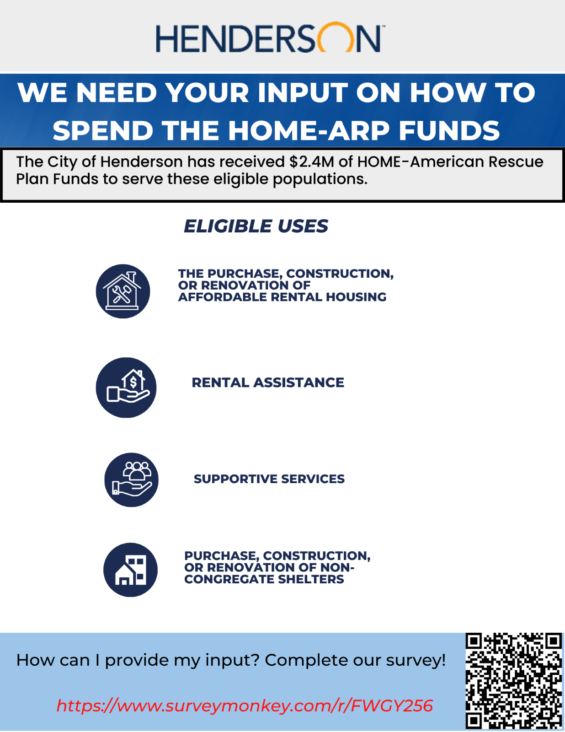

Attachment C: Infographic & Link to survey (Spanish)
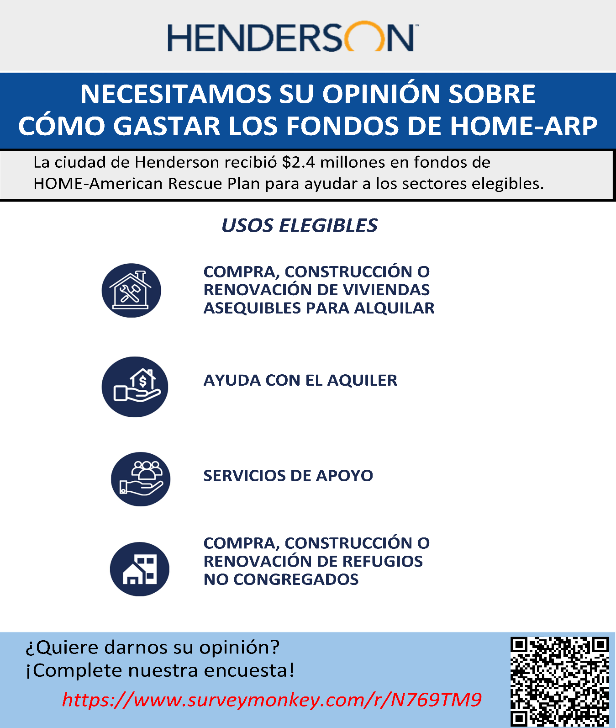

Attachment D: Community Feedback Survey (English)
HOME ARP Funding – Community Feedback Survey
City of Henderson, Nevada
Posted on City of Henderson Website

The U.S. Department of Housing and Urban Development (HUD) has provided the City of Henderson, Nevada $2.5 million through the Home Investments Partnerships (HOME) Program American Rescue Plan (ARP) funds to help: homeless individuals or families or those at risk of being homeless; individuals fleeing, or attempting to flee domestic violence, dating violence, sexual assault, stalking, or human trafficking; or veterans that meet one of the groups mentioned above.

The eligible uses of these funds are:

- The purchase, construction, or renovation of affordable rental housing

- Rental assistance

- Supportive Services (i.e., Homelessness prevention, case management, legal services, childcare, education services)

- The purchase, construction, or renovation of non-congregate shelter. Non-congregate shelters provide private units or rooms as temporary shelter to individuals and families and do not require occupants to sign a lease or occupancy agreement

Your input will help the City prioritize how it uses these funds.

- Please rank which of the following groups have the greatest need (1 is the greatest need and 5 is the lowest need).
  - A homeless individual or family who lacks a fixed, regular, and adequate nighttime residence
  - An individual or family that is at risk of homelessness and does not have sufficient resources or support networks to prevent them from moving to an emergency shelter
  - Individuals or families that would benefit from supportive services or assistance to prevent homelessness or housing instability
  - An individual fleeing, or attempting to flee domestic violence, dating violence, sexual assault, stalking, or human trafficking
  - Veterans that meet one of the four groups mentioned above

- Please rank up to five affordable housing priorities with the greatest need (1 is the greatest need and 5 is the lowest need).
- Building new single-family housing
- Building new rental multifamily housing
- Renovating and repairing rental single-family housing
- Renovating and repairing rental multifamily housing
- Critical or emergency home repairs
- Purchasing and renovating single-family or multifamily housing
- Purchasing and renovating single-family or multifamily housing for resale
- Assistance with rental payments
- Housing together with supportive services to help achieve housing stability
- Purchasing and building shelters that provide temporary private units or rooms to individuals and families

- Please rank up to five supportive services with the greatest need (1 is the greatest need and 5 is the lowest need).
- Basic educational services, like English as a Second Language (ESL) classes, adult literacy, high school equivalency, and instructional materials
- Childcare
- Meals or groceries
- Housing search and counseling services to find and stay in stable housing
- Mediation between tenants and landlords
- Legal services
- Employment assistance and job training
- Life management skills
- Credit repair
- Mental health services
- Health services
- Substance abuse treatment services
- Outreach to provide immediate support and intervention
- Transportation
- Case management to provide individualized services
- Mediation between the program participant and the owner or cohabitants like roommates or significant others
- Services for special populations, like victim services offered at rape crisis centers or domestic violence shelters
- Financial assistance to cover costs like rental fees, security deposits or utility payments
- Short-term and medium-term assistance with rental payments

- Are there any other unmet needs that have not been listed above?

[Paragraph for response]

Thank you for taking the survey. If you have any questions, please email us at daniel.steklasa@cityofhenderson.com.

Attachment E: Community Feedback Survey (Spanish)
Financiamiento de HOME ARP - Encuesta de opinión de la comunidad
Ciudad de Henderson, Nevada
Publicado en el sitio web de la Ciudad de Henderson
El Departamento de Vivienda y Desarrollo Urbano de los EE. UU. (Department of Housing and Urban Development, HUD) dio a la Ciudad de Henderson, Nevada, $2.5 millones mediante fondos del Plan de Rescate Estadounidense (ARP) del Programa Home Investments Partnerships (HOME) para ayudar a: personas o familias sin vivienda o en riesgo de quedarse sin ella; personas que huyen o intentan huir de la violencia doméstica, la violencia en el noviazgo, la agresión sexual, el acoso o la trata de personas; o a veteranos que pertenezcan a alguno de los grupos mencionados arriba. Su opinión ayudará a la Ciudad a priorizar el uso de estos fondos.
Los usos elegibles de estos fondos son:

- La compra, la construcción o la renovación de viviendas asequibles para alquilar.

- Ayuda con el alquiler.

- Servicios de apoyo (por ejemplo, prevención de la falta de vivienda, administración de casos, servicios legales, cuidado infantil, servicios educativos).

- La compra, la construcción o la renovación de refugios no congregados. Los refugios no congregados ofrecen unidades o habitaciones privadas como refugio temporal para individuos y familias, y no requieren que los ocupantes firmen un contrato de alquiler u ocupación.

Su opinión ayudará a la Ciudad a priorizar el uso de estos fondos.

- Clasifique cuál de los siguientes grupos tiene la mayor necesidad (1 es la mayor y 5 es la menor).
  - Una persona o familia sin vivienda que no tiene una residencia nocturna fija, habitual y adecuada.
  - Una persona o familia que está en riesgo de quedarse sin vivienda y que no tiene recursos o redes de apoyo suficientes para evitar el traslado a un refugio de emergencia.
  - Personas o familias que se beneficiarían de servicios de apoyo o asistencia para prevenir la falta de vivienda o la inestabilidad de la vivienda.
  - Una persona que huye o intenta huir de la violencia doméstica, la violencia en el noviazgo, la agresión sexual, el acoso o la trata de personas.
  - Veteranos que pertenezcan a uno de los cuatro grupos mencionados arriba.

- Clasifique hasta cinco prioridades de vivienda asequible con la mayor necesidad (1 es la mayor y 5 es la menor).
- Construcción de nuevas viviendas unifamiliares.
- Construcción de nuevas viviendas multifamiliares de alquiler.
- Renovación y reparación de viviendas unifamiliares de alquiler.
- Renovación y reparación de viviendas multifamiliares de alquiler.
- Reparaciones críticas o de emergencia en la vivienda.
- Compra y renovación de viviendas unifamiliares o multifamiliares.
- Compra y renovación de viviendas unifamiliares o multifamiliares para su reventa.
- Asistencia para pagar el alquiler.
- Vivienda y servicios de apoyo para ayudar a lograr la estabilidad de la vivienda.
- Compra y construcción de refugios que sirvan como unidades o habitaciones privadas temporales para personas y familias.

- Clasifique hasta cinco servicios de apoyo con la mayor necesidad (1 es la mayor y 5 es la menor).
- Servicios educativos básicos, como clases de inglés como segundo idioma (ESL), alfabetización de adultos, equivalencia de escuela secundaria y materiales de enseñanza.
- Cuidado infantil.
- Comidas o comestibles.
- Servicios de búsqueda de vivienda y asesoramiento para encontrar y mantener una vivienda estable.
- Mediación entre inquilinos y propietarios.
- Servicios jurídicos.
- Asistencia con el empleo y capacitación laboral.
- Competencias de gestión de la vida.
- Reparación de crédito.
- Servicios de salud mental.
- Servicios de salud.
- Servicios para el tratamiento del abuso de sustancias.
- Asistencia e intervención inmediatas.
- Transporte.
- Gestión de casos para prestar servicios individualizados.
- Mediación entre el participante en el programa y el propietario o convivientes como compañeros de piso
o parejas.
- Servicios para poblaciones especiales, como los que se ofrecen a las víctimas en los centros de crisis por violación o en los refugios para víctimas de violencia doméstica.
- Asistencia económica para cubrir costos como alquileres, depósitos de garantía o pagos de servicios públicos.
- Asistencia de corto y mediano plazo con el alquiler.

- ¿Hay otras necesidades no cubiertas que no estén listadas arriba?

[Párrafo de respuesta]

Gracias por tomar la encuesta. Si tiene alguna pregunta, envíenos un email a daniel.steklasa@cityofhenderson.com.

Attachment F: Henderson HOME-ARP Presentation
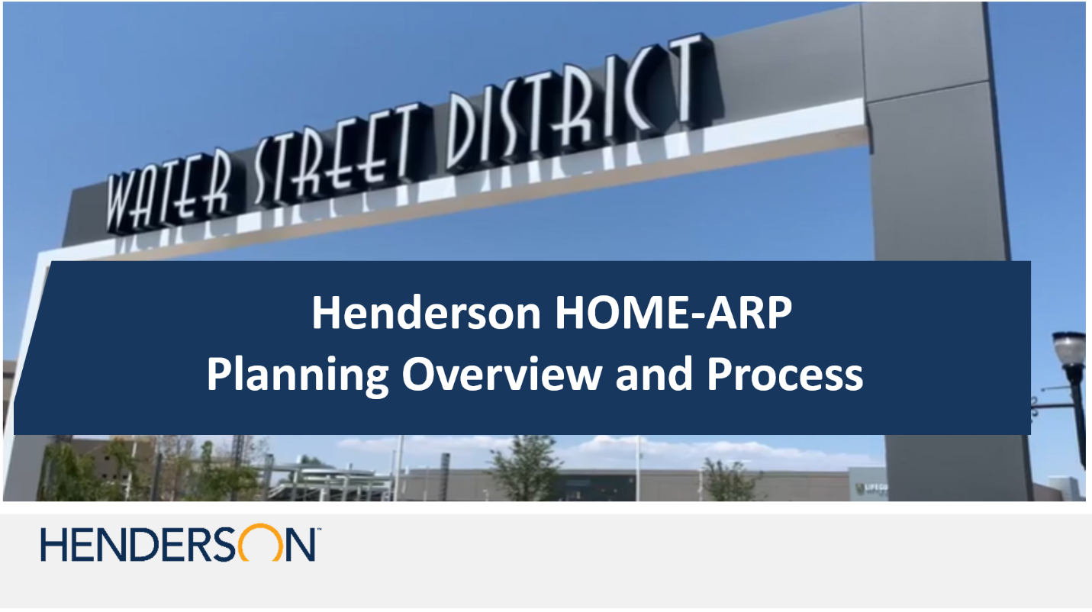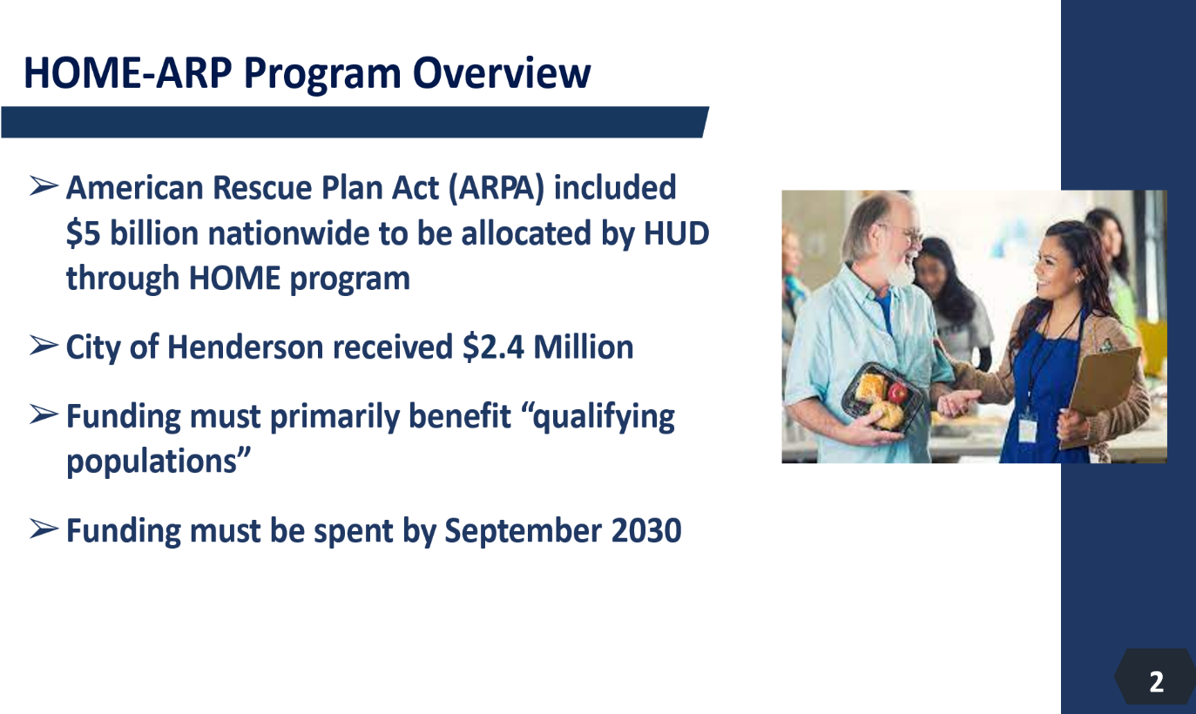

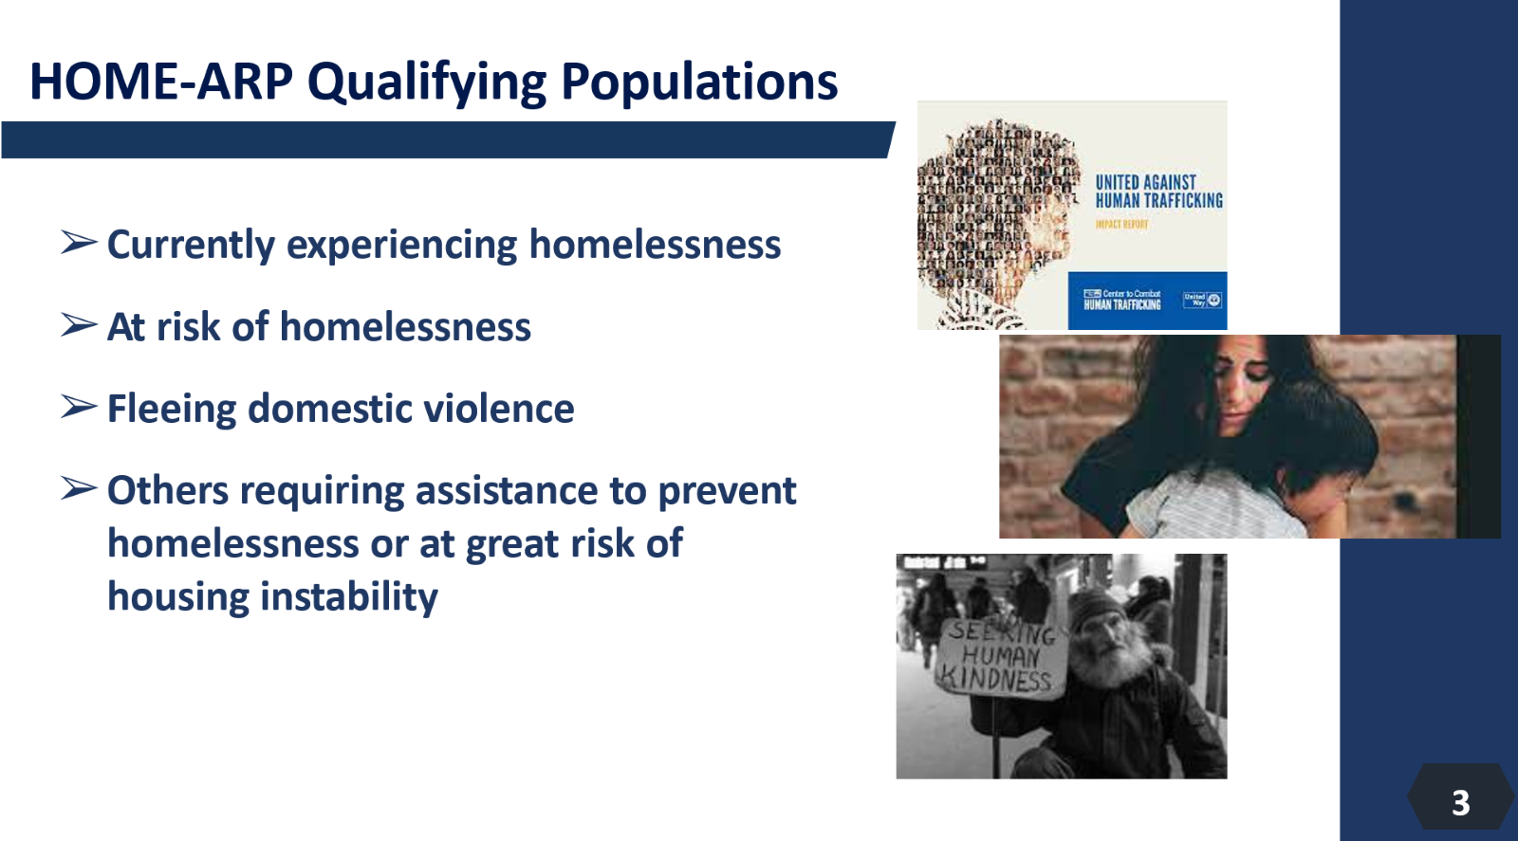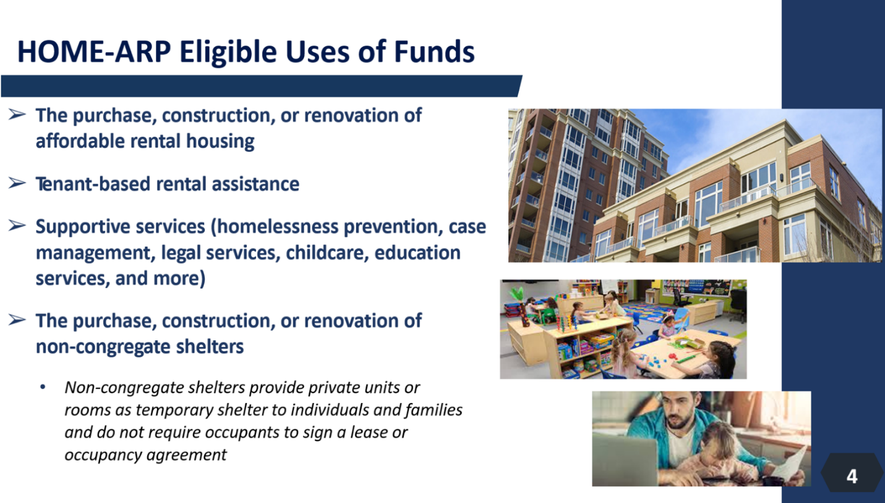

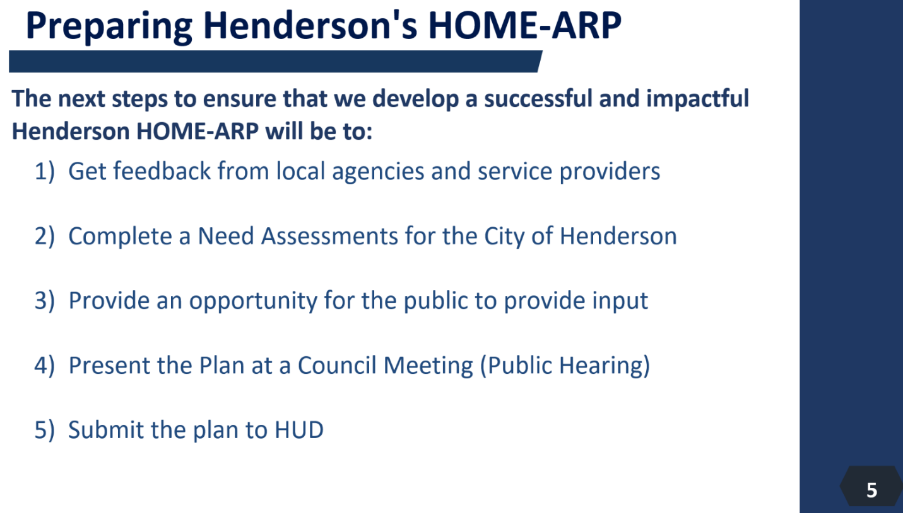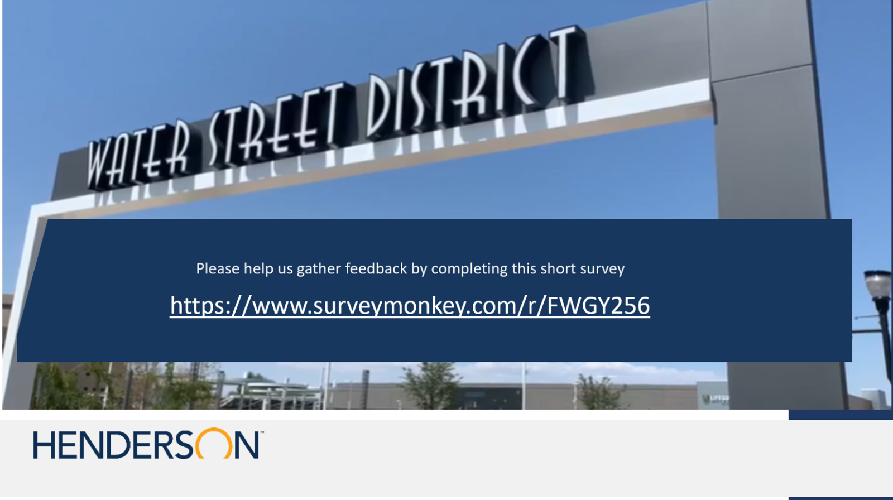

Attachment G: Southern Nevada Continuum of Care Data
