CITY OF HENDERSON COMMUNITY DEVELOPMENT AND SERVICES DIRECTOR RECEIVES PRESTIGIOUS PLANNING AWARD

Corrado recognized for years of public service and professional contributions

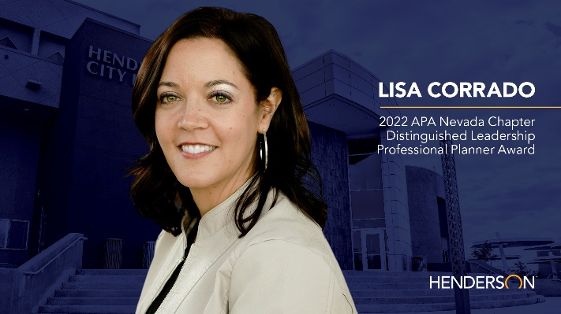

HENDERSON, Nev. (Oct. 19, 2022) – The City of Henderson’s Director of Community Development and Services Lisa Corrado today earned a prestigious industry award for Distinguished Leadership – Professional Planner by the Nevada Chapter of the American Planning Association (APA) during its annual conference.

The Distinguished Leadership – Professional Planner award recognizes Nevada planning professionals for sustained contributions to the profession through distinguished practice, teaching, or writing.

“Over the last fifteen years, I have made a conscious effort to build a vibrant, livable community that aligns with the City’s vision to guide the physical development of our great city,” said Corrado. “This is an incredible recognition, and my hope is to continue to lead and make transformative changes to improve the quality of life for our residents today, and into the future.”

Corrado’s well-deserved recognition spotlights her years of public service through effective, innovative, and strategic planning that continues to impact positively, not only the Henderson community but the Southern Nevada community as a whole.

As Director of Community Development and Services, Corrado expertly oversees high-quality development and service standards, progressive long-term city planning, quality building construction, as well as community outreach, housing, social service programs and code enforcement.

“Recently, I have expanded our role of traditional planning efforts to advocate for social issues, including addressing housing insecurity and homelessness, behavioral health needs, and substance misuse. This demonstrates how planners and innovative planning are vital to address challenges that directly impact our community,” Corrado continued.

She has provided planning expertise and policy guidance in the creation and implementation of the City’s Strategic Plan, the Southern Nevada Strong Regional Plan, the Henderson Strong Comprehensive Plan as well as the City’s recent COVID-19 Recovery Plan, among others.
““I have worked with Lisa on public planning initiatives for more than 15 years and it has been a pleasure watching her progress through her career to become a collaborative, innovative and engaged community leader,” said Mayor Debra March. “Kudos to Lisa on this well-deserved recognition and for inspiring young professionals to pursue leadership roles in their communities.”

In addition to her professional accomplishments and contributions, Corrado devotes time to mentoring other professionals through presentations and workshops at APA conferences, career development, continued education, and volunteer roles such as a former board member of the Nevada Chapter of the APA and board member of the Nevada Housing Coalition.

The APA comprises more than 40,000 members nationwide and is an independent, not-for-profit educational organization that provides vital leadership in creating great communities for all. APA and its professional institute, the American Institute of Certified Planners, are dedicated to advancing the profession of planning, offering better choices for where and how people work and live.

###

ABOUT THE CITY OF HENDERSON
Incorporated in 1953, Henderson is Nevada’s second-largest city with more than 332,000 residents. Henderson is a premier city, nationally recognized for its stunning parks, trails, master-planned communities, outstanding quality of life and patriotic past. Recognized as one of America’s Best Places to Live (MONEY and Liveability.com), one of America’s Best Cities (Business Week), one of the safest cities in America (Forbes, InsuranceProviders.com, Law Street Media, Movato.com), and a Bicycle Friendly Community (League of American Bicyclists), Henderson is a progressive and vibrant city committed to maintaining premier amenities and services for all who choose to live, learn, work and play in Henderson … a place to call home.

MEDIA CONTACT
Maddie Skains
Senior Public Information Officer | City of Henderson
Madeleine.skains@cityofhenderson.com
O: 702-267-4035 | C: 702-277-3836

