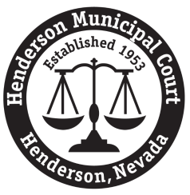
HENDERSON MUNICIPAL COURT
243 Water Street, 3rd Floor
Henderson, NV 89015
Phone: (702) 267-3300 Fax: (702) 267-3301
HMCCS@cityofhenderson.com
Today’s Date: ______ / ______ / ______
Records Request (see note below) Audio CD Request (see note below)
Defendant’s Name:
Date of Birth: | Social Security Number:
Case Number/Charge or Date of Arrest/Incident/Citation:

Records Requested:
Standard records request (includes court docket, complaint, admonishment (if applicable) and original sentencing order)
Other: ___________________________________________________________________________________
Certified copy of document(s) above (additional fee applies)
Hearing Date(s) – for audio CD requests only:
Note on Records Requests
- Per Nevada law, misdemeanor cases are destroyed once the applicable retention period has been satisfied.
- If records are no longer available, the Court will provide a letter free of charge.
Note on Audio CD Requests
- Audio CDs can only be played on a computer using FTR Player software; computers must have a CD drive, sound card, and Internet access. Audio CDs cannot be returned for a refund.
- To avoid tampering, courtroom audio is saved in a proprietary format (.TRM file extension) and will not play in standard CD players or with standard media players.
- After creating an account on the FTR website, you can either upload the files from the CD to the website using the free online Web Player, or you can download the free FTR Player software onto your computer.
Fees (non-refundable)
Copy: $0.50 per page/$1.00 minimum – fee must be paid before records are released
Certified copy with court seal: $3.00 per document – fee must be paid before records are released
Audio CD: $25 per CD – fee is due at the time of the request

Requestor’s Name:
Address:
City / State / Zip:
Phone / Fax Number / E-mail:
Return originals by mail Call when ready; I will pick up Fax copies (non-certified) E-mail (non-certified)

